YuviPep AI Sales Platform
Architecture and Technology Plan
Zero-Touch Sales Automation using AI Agents
Built as a multi-organisation platform
Purpose: replace manual Salesforce work with an AI app that listens, writes, schedules, and sends — with almost no typing. The same system serves many organisations, each kept fully separate.
Planning document · Version 2.0
First organisation: YuviPep · Designed so more organisations can join later

Contents
1. What We Are Building 3
2. Multi-Organisation Design 5
3. Who Uses the System (Actors and Roles) 8
4. The Lead Journey (Lead States) 10
5. The Big Picture (High-Level Architecture) 12
6. The AI Agents (The Brains of the System) 13
7. The Technology Stack (Python-Based) 15
8. Model Strategy: Gemini Now, Claude Later 17
9. How Each Job Works, Step by Step 18
10. What the System Stores (Data Model) 23
11. Scalability and Performance 25
12. Reliability and Correctness 28
13. Security and Access Control 29
14. Data Protection, Retention, and Compliance 31
15. Organisation Onboarding 32
16. What Else Is Possible (Extra Ideas) 33
17. Suggested Build Plan (Phases) 34
18. Things to Be Careful About 35
19. Summary 36

1. What We Are Building
Today, our sales staff use Salesforce by hand. They type meeting notes, create tasks, make proposals, send emails, and set reminders. This takes a lot of time and small things get missed.
We want to build a phone app that does almost all of this on its own. The salesperson just talks in the meeting and the app does the rest. We call this “zero-touch” — staff do very little manual work, and the AI handles the routine steps.
The app is built for many organisations from the start. When a person opens the app, they first choose their organisation. Everything after that stays inside that organisation, separate from all others. YuviPep is the first organisation; others can join later without any rebuild.
In short, the app should be able to:
- Let a person sign in and work inside their own organisation only.
- Listen to a meeting and turn the talk into clean text.
- Pull out the to-do items (action items) from that text, with an optional quick review before saving.
- Read a business card photo and save the contact details.
- Send a ready-made introductory message to the new contact, using the organisation’s own template.
- Create a proposal for the school right away, ready to edit.
- Edit the proposal by simple voice or text commands.
- Send the proposal by email from the salesperson’s own email, after a quick approval.
- Answer questions like “Show my open tasks” or “Show this week’s demos.”
- Write follow-up emails or WhatsApp messages and keep the lead updated.
One honest note: for messages going to clients, the app still asks the salesperson to tap “Approve and Send.” This one tap protects us from mistakes. So the real goal is “one-tap” rather than “zero-tap.” The AI does about 95% of the work; the human just confirms.

Example — a full meeting in one minute: Rahul (sales agent at YuviPep) opens the app, already set to YuviPep. He visits Delhi Public School, meets the Principal, and taps Record. They talk for 30 minutes. He snaps a photo of the Principal’s business card and taps Stop.
Within a minute the app shows the full text of the talk, a list of 4 action items, the Principal’s saved contact, and a ready IBC proposal. A short introductory message is drafted for the Principal. Rahul says “Make it 16 workshops at Rs 1500 per year.” The app updates the proposal. He taps Approve and Send. The proposal email goes out from rahul@yuvipep.com to the Principal, with the Owner in CC. Total typing by Rahul: zero.

2. Multi-Organisation Design
This is the most important idea in the design, so we explain it first. Everything else is built on top of it.

2.1 The simple idea
An “organisation” (also called a “tenant”) is one company that uses our platform. YuviPep is the first. Each organisation gets its own private space inside the same app. Staff of one organisation never see anything that belongs to another.
The key rule: every record in the system — every lead, task, proposal, contact, recording, and message — is stamped with an organisation id (org_id). Nothing exists without one. When the app asks for data, it can only ever get back rows that carry the org_id of the person who is logged in.

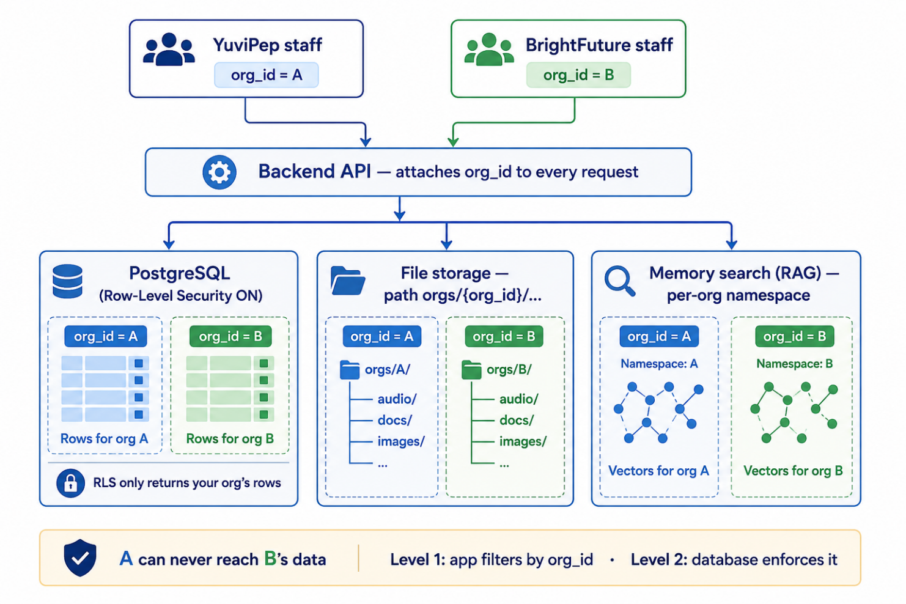

2.2 How a person lands in the right organisation
- At sign-in, the app shows the organisation (typed once and remembered, or chosen from a list). YuviPep staff pick YuviPep.
- The person logs in with their official company email. The email also tells us the organisation (for example, anything ending in @yuvipep.com belongs to YuviPep).
- From that moment, the app carries the org_id with every request. The Backend API attaches it before any work begins.
- If one person genuinely works for two organisations, the app shows a simple “switch organisation” option. By default, one person belongs to one organisation.

Example — two organisations, fully separate: YuviPep and a second company, BrightFuture Labs, both use the platform.
Rahul (YuviPep) logs in and sees only YuviPep schools, pricing, and teams. Meena (BrightFuture) sees only BrightFuture data. Even if both have a lead called “Green Valley School,” they are two different records under two different org_ids. Neither can ever see the other’s. The pricing, templates, and sending email addresses are different for each.

2.3 What is shared and what is separate
We share the machinery but keep the data apart. This keeps cost low and isolation strong.

Thing | Shared or separate? | Why
App code and AI agents | Shared | One codebase serves everyone; cheaper to run and improve.
Database engine | Shared | One PostgreSQL cluster, but every row carries org_id and is fenced off (see 2.4).
Lead, task, proposal, contact data | Separate per organisation | Private business data; it must never cross over.
Programs, pricing, proposal & message templates | Separate per organisation | Each company sells different things at different prices.
Teams, users, roles | Separate per organisation | Each company has its own staff.
Email, WhatsApp, calendar settings | Separate per organisation | Each company sends from its own accounts.
Memory / past-notes search (RAG) | Separate per organisation | One company’s notes must never appear for another.
File storage (audio, cards, proposals) | Separate per organisation | Files are saved under a per-organisation folder path.

2.4 How we keep organisations apart (the safety net)
We protect data isolation at two levels, so a single bug can never leak data across organisations:
Level 1 — the app always filters by org_id. Every database query the Backend API runs includes the logged-in person’s org_id. This is the everyday protection.
Level 2 — the database itself enforces it (Row-Level Security). PostgreSQL Row-Level Security (RLS) is switched on so the database only returns rows matching the current org_id — even if a developer forgets a filter in the app. The database is the final guard.
Files and memory are namespaced too. Audio, card photos, and proposal files are stored under a path like orgs/{org_id}/… . The memory search keeps a separate namespace per organisation. So even outside the main database, nothing mixes.

Why two levels? Think of a bank locker room. Level 1 is the clerk who only brings you your own locker. Level 2 is that each locker still needs your own key. Even if the clerk makes a mistake, the lock stops you opening someone else’s locker. We want both.

2.5 Per-organisation settings
Each organisation has its own settings page (managed by its Admin). This is what makes the same app behave correctly for everyone:
- Branding: name, logo, and colours shown in the app and on proposals.
- Programs, pricing tables, and proposal templates.
- Introductory and follow-up message templates (with variables).
- Email sending setup (which Gmail or Outlook domain), WhatsApp number, and calendar.
- Feature switches — for example, “require review of action items: on/off.”
- Data settings — for example, how long recordings are kept (see Section 14).
- Staff, roles, and demo teams.

3. Who Uses the System (Actors and Roles)
Every person who uses the app logs in with their official company email. That email decides their organisation and their role. The role decides what they can see and do. This is called role-based access.
Two levels of roles: most roles live inside one organisation. One special role, the Super Admin, sits above all organisations and is run by us, the platform operator. The Super Admin is the only role that can create a new organisation; it does not read any organisation’s private sales data.

Role | Level | What they do | Simple example
Super Admin | Platform | Enrols new organisations and sets them up. Cannot read an organisation’s private leads. | Adds BrightFuture Labs as a new organisation.
Org Admin | Organisation | Sets up programs, templates, pricing, teams, users, and settings for their organisation. | YuviPep Admin adds the IBC program and its pricing.
Sales Agent | Organisation | Talks to the decision maker, records meetings, sends proposals. | Rahul records a school meeting and sends a proposal.
Decision Maker | External | The school’s Principal or Owner. Receives proposals. Does not log in. | Mrs. Sharma, Principal, gets the proposal email.
Sales Lead | Organisation | Manages a team of sales agents and reviews action items. | Siva checks all open tasks of his team.
Operations Agent | Organisation | Runs the school demos after a deal is agreed. | Sourav goes to the school to give the demo.
Operations Lead | Organisation | Manages demo teams and demo schedules. | Mithun assigns Team Alpha to a school.

Key rule: the email id is the identity, tied to one organisation. When Rahul sends a proposal, the system uses rahul@yuvipep.com as the sender. The school always sees a real person’s email, never a robot address, and never an address from another organisation.
This small set of roles is enough for the current size. As organisations grow past a few teams, the design leaves room for finer-grained, custom permissions and per-team data scoping — for example, letting an agent see only their own region. This is covered in Section 13.

4. The Lead Journey (Lead States)
A “lead” is a school we are trying to win. As we work on it, the lead moves through stages. Each stage is called a state. The app shows the current state and changes it as work happens.
The journey begins when a school becomes a lead and we have a first contact. From there, the states are:

Lead state | What it means | Example
Open | We have a contact but no real talk yet. | We have the Principal’s number, not met yet.
Active | We are in regular talks with the school. | Two meetings done, proposal discussed.
Active and Important | A high-value or high-priority active lead. | A 40-branch school chain — needs extra focus.
Cold | No reply for a long time; gone quiet. | No answer for 6 weeks.
Execution in Progress | Deal agreed; work is being set up. | Contract signed, preparing the rollout.
School Execution in Progress | The program is being run inside the school. | Workshops are now running at the school.
Closed | Deal is won and fully done. | Program delivered and paid.
Lost for Now | Did not win this time; may try later. | They chose another vendor this year.

Note: “Active and Important” is really “Active” plus an importance flag. We keep it as a named state here to match how staff talk, but in the data it is stored as the Active state with an “important” marker. This keeps the design clean.

4.1 The state diagram
The diagram below shows how a lead moves between states. Solid arrows are normal forward progress; dashed arrows are when a lead goes quiet, is lost, or is retried later.

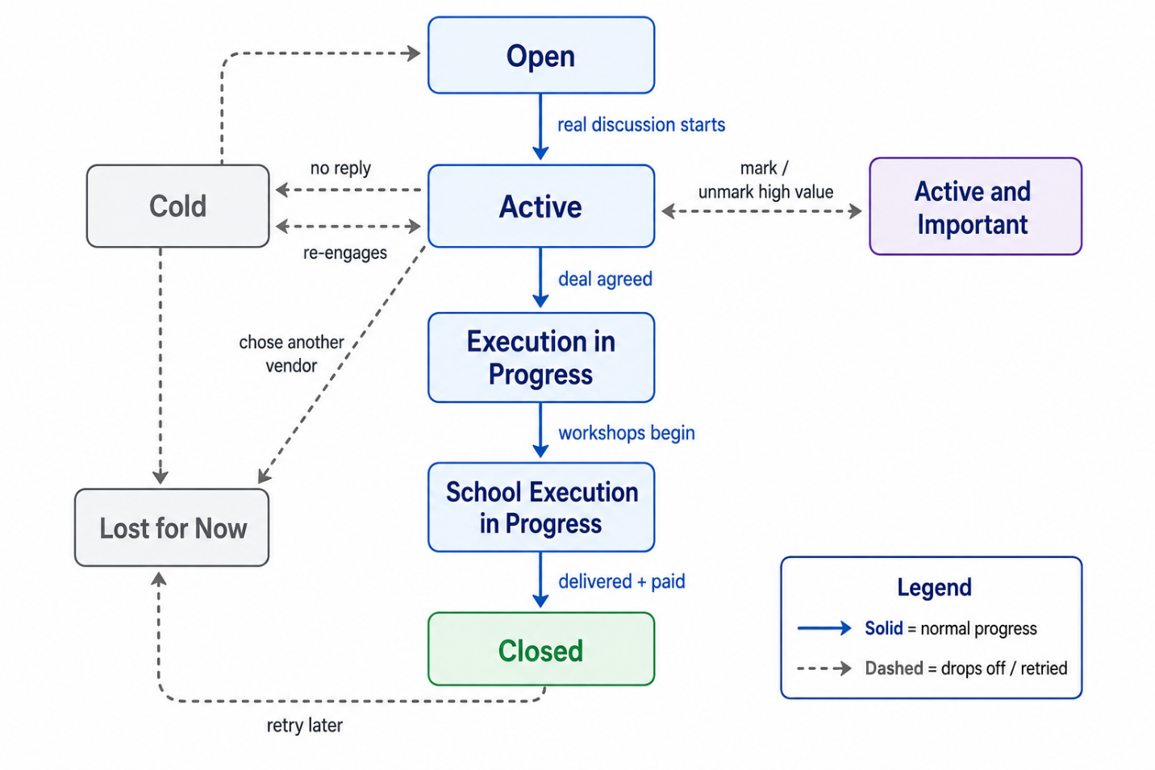

The salesperson rarely sets the state by hand. The system moves it based on what happens — for example, after a real recorded discussion it suggests moving “Open” to “Active.”

Example — how a state changes by itself: Green Valley starts as “Open.” After Rahul’s first recorded meeting, the AI sees real discussion and suggests moving it to “Active.” After the contract is signed, an Operations Lead marks it “Execution in Progress.” When workshops begin, it becomes “School Execution in Progress.” If they go quiet for weeks, it drifts to “Cold,” and a good follow-up can bring it back to “Active.”

5. The Big Picture (High-Level Architecture)
The system is built in layers. Each layer has one clear job and passes work to the next. Importantly, every layer is organisation-aware: the org_id travels from the top (the phone) all the way down to the database and outside services.

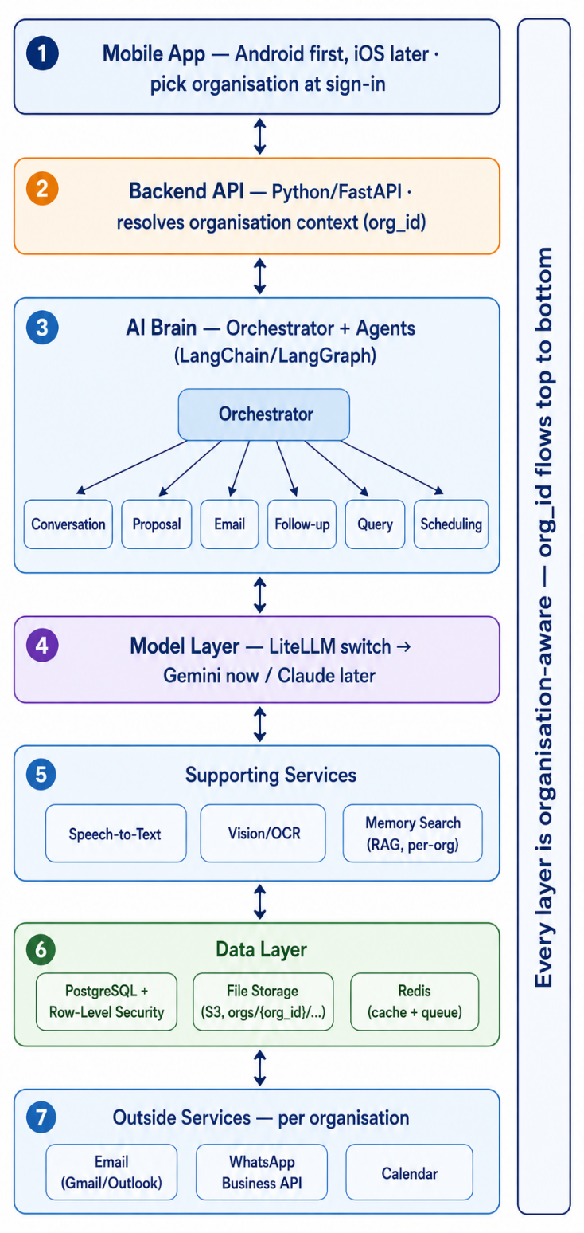

5.1 What each layer does
1) Mobile App. What staff use. At sign-in the person picks their organisation. It records meetings, takes the business card photo, takes voice or text commands, and shows proposals for review. We build Android (Java / Kotlin) first, then iOS.
2) Backend API. The control room, written in Python with FastAPI. It checks who is logging in and resolves the organisation context — it figures out the org_id for this user and attaches it to every request. It applies business rules and decides which AI agent should handle each request. Nothing reaches the AI without passing through here.
3) AI Brain (Orchestrator + Agents). A main “orchestrator” reads the request and hands it to the right specialist agent. Every agent is given the org_id so it only ever works on the right organisation’s data. More in Section 6.
4) Model Layer (LLM). The actual large language model that thinks and writes. One common switch (LiteLLM) lets us use Gemini now and Claude later without rebuilding. More in Section 8.
5) Supporting Services. Helpers: Speech-to-Text (audio to words), Vision/OCR (reads the card), and Memory Search (finds past notes). Memory Search keeps a separate namespace per organisation.
6) Data Layer. Where everything is saved: PostgreSQL for records (org_id on every row, Row-Level Security on), file storage for audio, cards, and proposals (per-organisation folders), and Redis for both caching and a background job queue (with Celery).
7) Outside Services. The real-world tools we connect to: email (Gmail or Outlook), WhatsApp, and the calendar — each set up per organisation.

6. The AI Agents (The Brains of the System)
An “agent” is a small AI worker with one job. Instead of one giant program that tries to do everything, we use several focused agents. A main “orchestrator” sits on top and sends each task to the right worker. This is built using LangChain and LangGraph (popular AI agent frameworks for Python).
Each agent is given a set of “tools.” A tool is an action the agent may take — like “save action item,” “send email,” or “look up demo schedule.” Every tool call carries the org_id, so an agent can only act inside the right organisation.

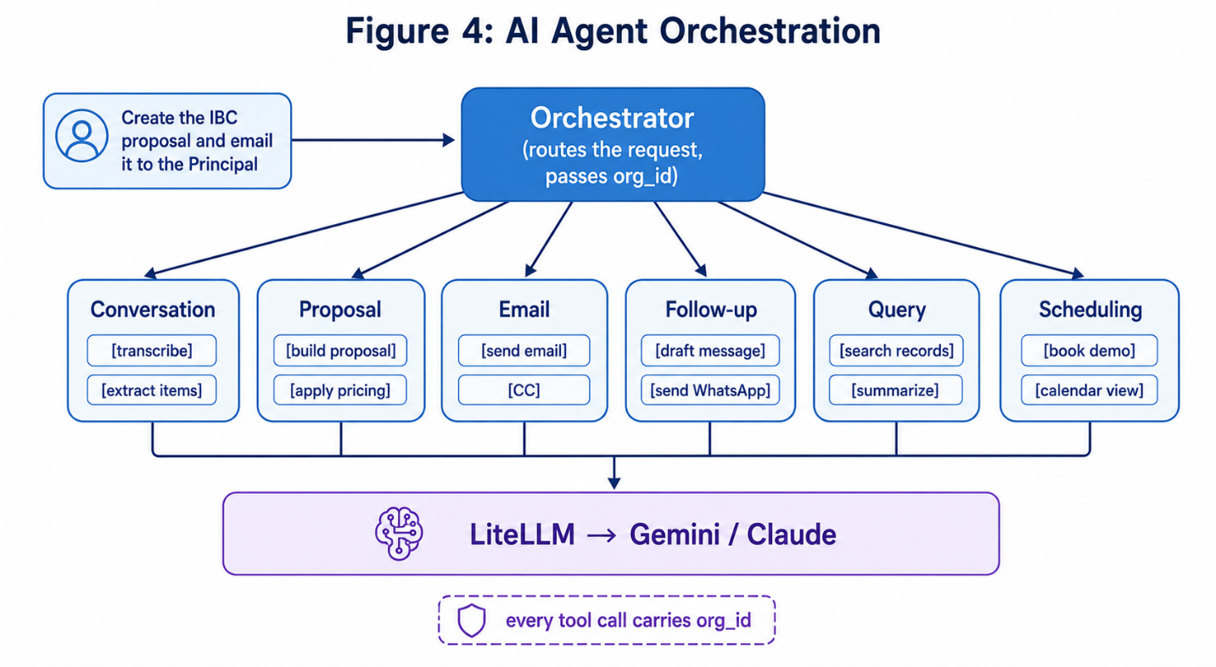

Agent | Its job | Example of it working
Orchestrator | Reads the request and routes it to the right agent; always passes the org_id along. | Hears “send the proposal” and passes it to the Email Agent.
Conversation Agent | Turns audio into text, finds action items, updates school notes. Can pause for review if that is switched on. | Creates 4 tasks from a 30-minute meeting.
Proposal Agent | Builds and edits proposals from the organisation’s template and pricing. | Makes an IBC proposal, then changes it to 16 workshops.
Email Agent | Drafts and sends emails from the agent’s own email; handles CC; also sends the introductory message from a template. | Sends proposal to Principal, CC the Owner.
Follow-up Agent | Writes follow-up emails and WhatsApp messages for a lead. | Drafts a polite “just checking in” message.
Query Agent | Answers questions by reading the database in plain language, always scoped to the org_id. | “List my open tasks” returns a clean list.
Scheduling Agent | Handles demo dates and follow-up appointments; supports list and calendar views. | Books a demo for next Tuesday and tells the team.

The introductory message: when the Vision/OCR reads a business card, the Email Agent (or the Follow-up Agent for WhatsApp) can also send a short introductory message to that new contact. The message comes from the organisation’s template, and the variables (name, school, sender, program) are filled in automatically. Like all client messages, it is shown for a one-tap approval before sending.
Why split into many agents? Smaller agents are easier to test, cheaper to run, and safer. If one agent makes a mistake, it does not break the others. We can also improve one agent without touching the rest.

Example — agents working together: Rahul says: “Create the IBC proposal, make it 16 workshops at Rs 1500, and send it to the Principal with the Owner in CC.”
The Orchestrator splits this and tags every step with YuviPep’s org_id. The Proposal Agent builds the IBC proposal using YuviPep’s template and pricing, and applies the edits. The system shows it to Rahul for approval. After he taps Approve, the Email Agent sends it from his email, Principal in To, Owner in CC. Three steps, one sentence, no typing.

7. The Technology Stack (Python-Based)
This table lists the main tools we plan to use, what each is for, and why we picked it. The core is Python, because the AI frameworks (LangChain, LangGraph) and the Gemini and Claude libraries are best supported there.

7.1 Core stack

Layer | Tool / Technology | Why we use it
Mobile app | Android (Java / Kotlin) first; iOS later | Most staff use Android.
Backend | Python with FastAPI | Fast, modern, easy to connect to AI libraries.
Multi-tenancy | org_id on every table + PostgreSQL Row-Level Security | Keeps each organisation’s data fully separate.
AI agents | LangChain + LangGraph | Build and control multiple AI agents and their tools.
LLM (brain) | Gemini API now; Claude API later | Gemini to start; switch to Claude when ready.
Model switch | LiteLLM | One common code path for any model; easy to swap.
Speech-to-text | Whisper (self-host) or Deepgram / Google STT | Turns meeting audio into accurate text, incl. Indian accents.
Vision / card reading | Gemini or Claude vision, or Google Vision OCR | Reads a business card photo into name, email, phone.
Database | PostgreSQL | Reliable store for leads, tasks, proposals, users.
Caching | Redis (read cache + queues) | Speeds up repeated lookups and runs background jobs.
Memory search (RAG) | pgvector with HNSW; Pinecone / Qdrant later | Lets the AI recall past notes; clear path to scale (Section 11).
Documents | python-docx, WeasyPrint / ReportLab | Builds editable proposals and PDF files.
Email | Gmail API / Microsoft Graph | Send from the agent’s real email; manage CC.
WhatsApp | WhatsApp Business (Cloud) API or Twilio | Send follow-up and introductory messages.
Calendar | Google Calendar / Microsoft Graph | Book demos and follow-up appointments.
File storage | Amazon S3 or Google Cloud Storage (per-org paths) | Hold audio, card photos, and proposal files.
Background jobs | Celery + Redis | Run slow tasks (like transcription) in the background.
Observability | LangSmith or Langfuse + logging/metrics | Watch what agents do; catch errors and cost.
Login / access | OAuth + JWT, role-based access, org-scoped | Tie each login to an email, a role, and an organisation.
Hosting | AWS / Google Cloud (containers, India region) | Run safely, scale when needed, keep data in-country.

7.2 Other good options (for later)
- CrewAI or AutoGen — other agent frameworks if LangGraph does not fit a need.
- LlamaIndex — a strong tool for memory search if pgvector is outgrown.
- Pydantic — makes the AI return clean, structured data (so action items always have the right fields).
- PgBouncer + read replicas — to handle many organisations and heavy reads (Section 11).
- Salesforce sync — push data into Salesforce during the changeover period if needed.

8. Model Strategy: Gemini Now, Claude Later
We will start with the Gemini API and later move to the Claude API as our main brain. We do not want to rewrite the app when we switch. So we put a thin layer (LiteLLM) between our agents and the model. Our agents always talk to this layer; the layer talks to whichever model we choose.
Switching models then becomes a one-line setting change — not a rebuild.

Example — the model switch: Think of LiteLLM like a universal power adapter. Our app plugs into the adapter. Today it is set to “Gemini.” Tomorrow we flip it to “Claude.” The app keeps working the same way.
In settings today: MODEL = "gemini-2.5-pro"
In settings later: MODEL = "claude-opus-4-8"

Saving money with model tiers: we can use a cheap, fast model for simple steps (“list my tasks”) and the strongest model only for important proposals. Because the choice lives in settings, we can even set a different model per organisation. How we keep the number and cost of model calls under control is covered in Section 11.

9. How Each Job Works, Step by Step
This section walks through every main job. Each is broken into clear steps, with a full example. Every step happens inside the logged-in person’s organisation only.

9.1 Meeting with decision makers and proposal sharing
This is the most important flow. The salesperson records the meeting and the system does the rest.

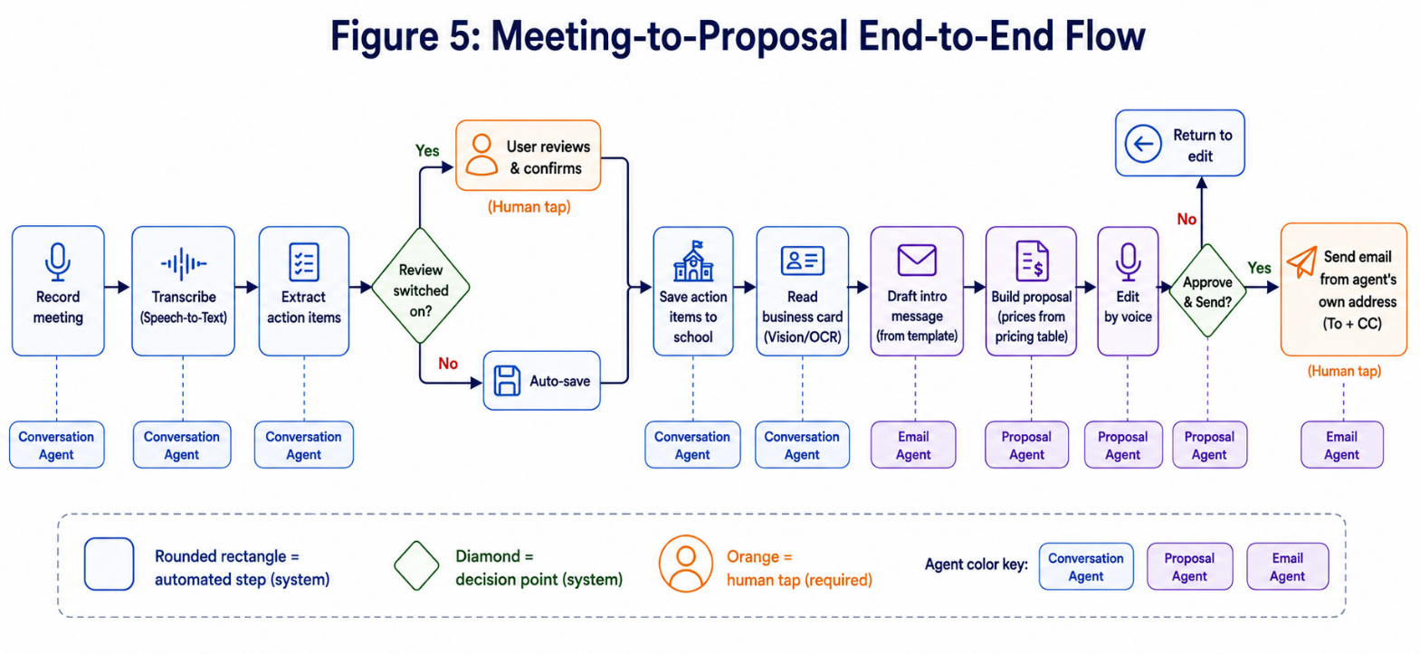

- Record the meeting in the app and stop when done.
- The system turns the audio into clean text (transcript).
- The AI reads the text and pulls out the action items.
- If the organisation has “review action items” switched on, the app shows the list first so the user can edit, add, remove, or confirm them. If it is switched off, the items are saved automatically. This can also be set per user.
- Action items are saved against the correct school, with full context.
- The decision maker’s details (name, phone, email) are saved on the record.
- A photo of the business card can be taken; the AI reads it and fills in the contact.
- An introductory message is drafted for the new contact from the organisation’s template, variables filled in, ready to approve and send.
- Based on the program, a proposal is created at once, ready to edit. Prices come straight from the pricing table, not from the AI (see Section 12).
- The salesperson can edit it by command, e.g. “make the workshops 16 and the price Rs 1500 per year.”
- The system asks for approval and shows a Review and Send option.
- The email goes to the main person (To), and any others go in CC. The sender is the salesperson’s own email id.
- The salesperson can add extra information about the school at any time — either by speaking to the agent (“add a note: they prefer Hindi-medium”) or by typing it in. Both ways work.

Full example, start to end:
- Rahul (signed in to YuviPep) visits Delhi Public School and meets Mrs. Sharma (Principal) and Mr. Verma (Owner). He taps Record.
- They talk for 30 minutes. Rahul snaps a photo of Mrs. Sharma’s business card and taps Stop.
- The app uploads the audio. Speech-to-Text returns the full transcript.
- The Conversation Agent finds 4 action items. Because YuviPep has review switched on, the app shows them; Rahul taps Confirm. They are saved under “Delhi Public School.”
- Vision/OCR reads the card: Name = Mrs. Sharma, Email = principal@dps.edu, Phone = 98xxxxxx. Saved to the contact.
- An introductory message is drafted: “Dear Mrs. Sharma, it was a pleasure meeting you today… — Rahul, YuviPep.” Rahul taps Approve; it is sent.
- The Proposal Agent builds an IBC proposal using YuviPep’s template and the IBC pricing table.
- Rahul says: “Make the workshops 16 and set the price to Rs 1500 per year.” The proposal updates instantly.
- The app shows a preview and asks: “Approve and send?” Rahul taps Approve and Send.
- The email is sent from rahul@yuvipep.com to principal@dps.edu, with owner@dps.edu in CC.
- Later Rahul says: “Add a note — school prefers Hindi-medium workshops.” The system saves this as school intelligence. He could have typed it instead.

9.2 Status fetch (action items)
This flow lets a person check and manage their tasks just by asking.
- Ask the app to list all action items in your name.
- While reviewing, change the owner of a task to someone else (say, Siva).
- Close a task by adding your response/result.

Full example:
- Rahul says: “Show my open action items.”
- The Query Agent returns: (1) Send IBC proposal to DPS, (2) Call Green Valley, (3) Share demo dates with Sunrise School.
- Rahul says: “Move task 2 to Siva.” The owner of “Call Green Valley” changes to Siva, and Siva is notified.
- Rahul says: “Close task 1. Proposal sent and Principal confirmed receipt.” The task is marked done with that note saved.

9.3 School demo details
This flow shows demos and the teams that run them, as a list or as a month calendar.
- List all committed schools and their demo dates.
- List all demo teams.
- List the schedule of each demo team.
- Switch to a calendar view — a full month (up to 31 days) showing demos on each date, so free and busy days are easy to see.

Full example:
- Mithun (Operations Lead) asks: “Show committed schools and demo dates.” The app returns: DPS – 12 July, Green Valley – 15 July, Sunrise – 18 July.
- He asks: “Show demo teams.” The app returns Team Alpha, Team Beta.
- He asks: “Show Team Alpha’s schedule.” The app returns: 12 July – DPS, 18 July – Sunrise.
- He taps “Calendar view.” July is shown as a 31-day grid with DPS on the 12th and Sunrise on the 18th marked for Team Alpha. He can instantly see Team Alpha is free on 15 July.

9.4 Lead follow-up
This flow helps staff never miss a follow-up.
- Fetch the follow-up appointments that are due.
- Get a ready follow-up email or WhatsApp message for a specific lead.
- After sending, tell the system, so it updates the lead and sets the next reminder.

Full example:
- Rahul asks: “Which follow-ups are due today?” The app lists: Green Valley and Sunrise.
- He says: “Write a WhatsApp follow-up for Green Valley.” The Follow-up Agent drafts a short, polite message that mentions the last meeting.
- Rahul taps Approve. The message is sent on WhatsApp.
- The system marks the follow-up done, saves the message, and sets the next reminder for one week later.

9.5 Administrative actions (backend setup)
These are the setup jobs done by an Org Admin. They control how that organisation behaves. Creating the organisation itself is done once by the Super Admin (Section 15).
- Register staff (Sales Agent, Operations Agent, Sales Lead, Operations Lead).
- Set access privileges for each person (what they can see and do).
- Add or update many proposal templates per program (e.g. IBC can have two templates).
- Add or update introductory and follow-up message templates, with variables.
- Set or update the pricing table for each program.
- Add multiple programs (e.g. IBC is one program; more can be added).
- Register demo teams with their members and roles.
- Set feature switches, such as “require review of action items.”
Demo team record — the fields to store:

Field | Example value
Demo Team Name | Alpha
Lead | Mithun
Members | Sourav, Baski
Media Rep | Shyam Prasad
Sales Rep | Rahul Reddy

Full example:
- YuviPep’s Org Admin adds a new program “IBC” and uploads two proposal templates (a short one and a detailed one).
- Admin sets the IBC pricing table: base price per workshop, yearly price options.
- Admin uploads an introductory message template: “Dear {contact_name}, it was a pleasure meeting you at {school_name}… — {sender_name}, {org_name}.”
- Admin registers Rahul as a Sales Agent with “send proposal” rights but not “edit pricing” rights.
- Admin registers Team Alpha with Mithun as Lead, Sourav and Baski as Members, Shyam Prasad as Media Rep, Rahul Reddy as Sales Rep.
- Now when any YuviPep agent makes an IBC proposal, it uses these templates and this pricing automatically — and only inside YuviPep.

10. What the System Stores (Data Model)
Below are the main groups of information the system keeps. Each group is like a folder of records. They link to each other (for example, an action item links to a school and to an owner).
The one rule that runs through all of them: every record carries an org_id. The first group, Organisations, is the parent of everything else.

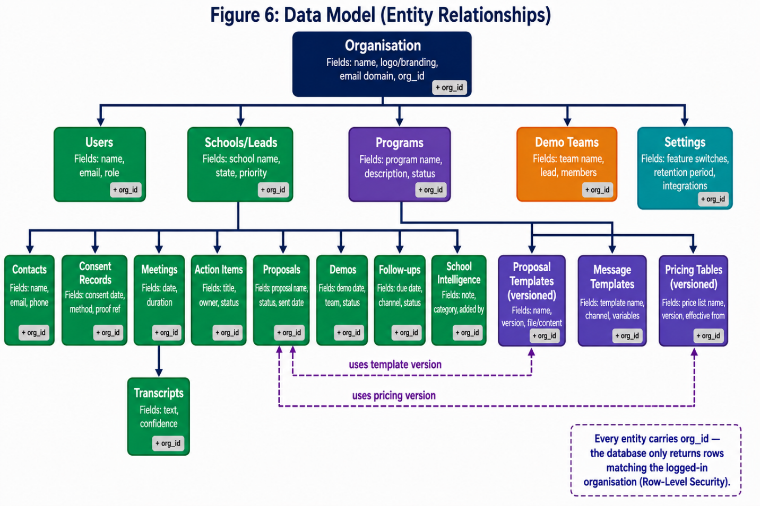

Record group | What it holds | Example
Organisations | Each company on the platform: name, branding, settings. Parent of all other records. | YuviPep; BrightFuture Labs.
Users / Roles | Each staff member, their email, role, and org_id. | Rahul – rahul@yuvipep.com – Sales Agent.
Schools / Leads | Each school, its state, and history (per org). | Delhi Public School – Active.
Contacts | Decision makers at a school (from cards). | Mrs. Sharma – Principal – principal@dps.edu.
Consent Records | Proof the contact was told about recording. | DPS meeting – consent captured 26 June.
Meetings | A recording, its transcript, and date. | DPS meeting on 26 June, 30 min.
Action Items | Tasks with owner, status, and result. | “Send proposal” – Rahul – Open.
Programs | The products an organisation sells. | IBC.
Proposal Templates | Templates per program (many allowed), versioned. | IBC short v2, IBC detailed v1.
Message Templates | Intro and follow-up templates with variables. | “Dear {contact_name}… — {sender_name}.”
Pricing Tables | Prices per program, versioned. | IBC – Rs 1500 / year (v3).
Proposals | A made proposal, its edits, and the template/price version used. | DPS IBC proposal – 16 workshops – price v3.
Demo Teams | Teams and their members/roles. | Alpha – Mithun, Sourav, Baski…
Demos | Scheduled demos and dates. | DPS demo – 12 July – Team Alpha.
Follow-ups | Reminders and sent messages. | Green Valley – due today.
School Intelligence | Free notes the agent adds (voice or typed). | “Prefers Hindi-medium workshops.”
Settings / Feature Switches | Per-organisation switches and config. | Review action items: ON.
Message Delivery Log | What was sent and its status (sent / delivered / failed). | Proposal email to DPS – delivered.
Activity / Audit Log | Who did what, and when. | Rahul sent proposal at 4:12 pm.

How the links work: Organisation → has many Users, Schools, Programs, Teams. School → has many Contacts, Meetings, Action Items, Proposals, Demos, Follow-ups, and Notes. Program → has Templates and a Pricing Table. Every row also stores the org_id directly, so the database can fence rows off even without following the links. Proposals copy the exact template and price version they used, so old proposals never change when pricing is updated later.

11. Scalability and Performance
PostgreSQL comfortably handles tens of millions of records with good indexing, so the database itself is not the main worry. The things that actually need a plan are the fastest-growing tables, the read cache, the memory store, the chain of AI calls, and the limits of outside services. We cover each below.

11.1 Indexing and query shape
Because we almost always search within one organisation, we index org_id together with the columns we filter and sort by — for example (org_id, owner, status) for action items and (org_id, state) for leads. Long lists use keyset pagination (fetch the next page from where the last one ended) instead of slow page offsets. Lead search uses PostgreSQL full-text search so finding a school by name stays fast.

11.2 The fastest-growing tables: partitioning and archival
Two tables grow far faster than the rest: Meetings/transcripts and the Message Delivery Log. Within months these will be the largest tables in the system. Plan:
- Split (partition) these tables by month, so each month sits in its own slice. A query for recent data only touches recent slices, never the whole history.
- Keep recent slices “hot” in the main database; after a set age (for example, older than a defined number of months) move slices to cheaper “cold” storage or archive the raw text to object storage.
- Raw audio is the heaviest item. It lives in object storage from day one, and can be deleted earlier than the transcript once it is no longer needed (see Section 14).

11.3 A real caching layer (not just queues)
Some data is read constantly but changes rarely: settings, pricing tables, templates, program lists, and user roles. We keep these in Redis as a read cache, with a short time-to-live and clear invalidation (the cache entry is cleared the moment an Admin changes the underlying value). This means a request like “show my tasks” or building a proposal does not hit PostgreSQL for the same configuration again and again. Each cache key includes the org_id.

11.4 Memory search (RAG) with clear thresholds
We start with pgvector and an HNSW index, which is fast for typical sizes. We do not leave scaling vague:
- Set targets: search must return in under a chosen time, with good recall.
- Set a threshold: when a single organisation’s notes pass a defined count, or those targets start to slip, that organisation’s memory moves to a dedicated vector store (Pinecone or Qdrant).
- Define the move: because memory is already namespaced per organisation, the migration is an export of that one namespace and an import into the new store — no change to the rest of the system.

11.5 The real bottleneck: the chain of AI calls
The database is rarely the slow part. Each meeting fires a chain of AI calls — transcribe, then extract action items, then build a proposal, then draft the intro and emails. At scale this chain is the main driver of both cost and waiting time. We manage it directly:
- Run the whole chain in the background (Celery), so the user never stares at a frozen screen; the app shows progress and updates as each step finishes.
- Use model tiers: a cheap, fast model for simple steps; the strong model only for proposals and important writing.
- Reuse work: do not re-transcribe; cache embeddings; let the model fill a template’s variables rather than write every proposal from scratch. Fewer and smaller calls.
- Limit concurrency to a worker pool sized to the model provider’s rate limit, so we never get throttled.
- Track tokens and cost per request, set a monthly budget per organisation, and raise an alert (or slow down) before a budget is exceeded.

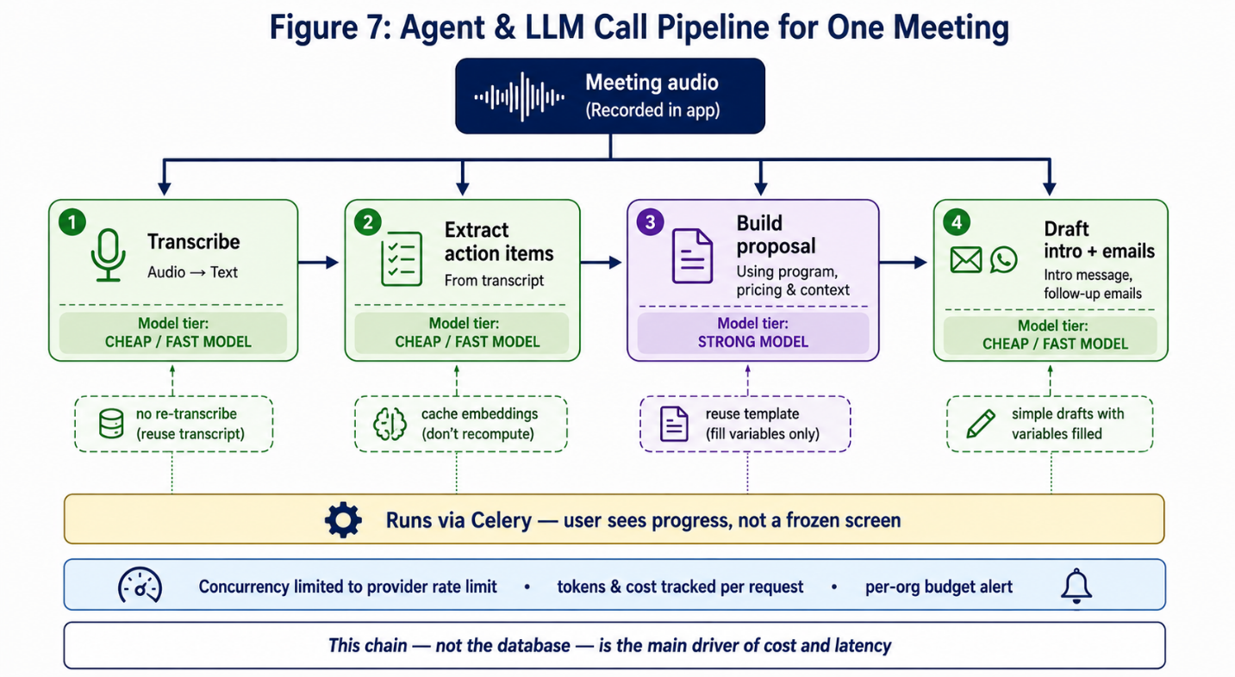

11.6 Outside API limits and backoff
Gmail/Outlook, WhatsApp Business, and Calendar all cap how many calls or sends are allowed per user and per day. We never fire sends directly at these services. Instead:
- All outbound messages go through a sending queue that respects each provider’s per-user and per-day limits.
- On a “too many requests” or temporary error, we wait and retry with exponential backoff (each retry waits longer).
- Sends are spread over time by a scheduler rather than fired all at once.
- Delivery status (queued, sent, delivered, failed, bounced) is tracked via provider webhooks and shown to the user.
- Messages that keep failing go to a dead-letter queue and raise an alert, so nothing fails silently.

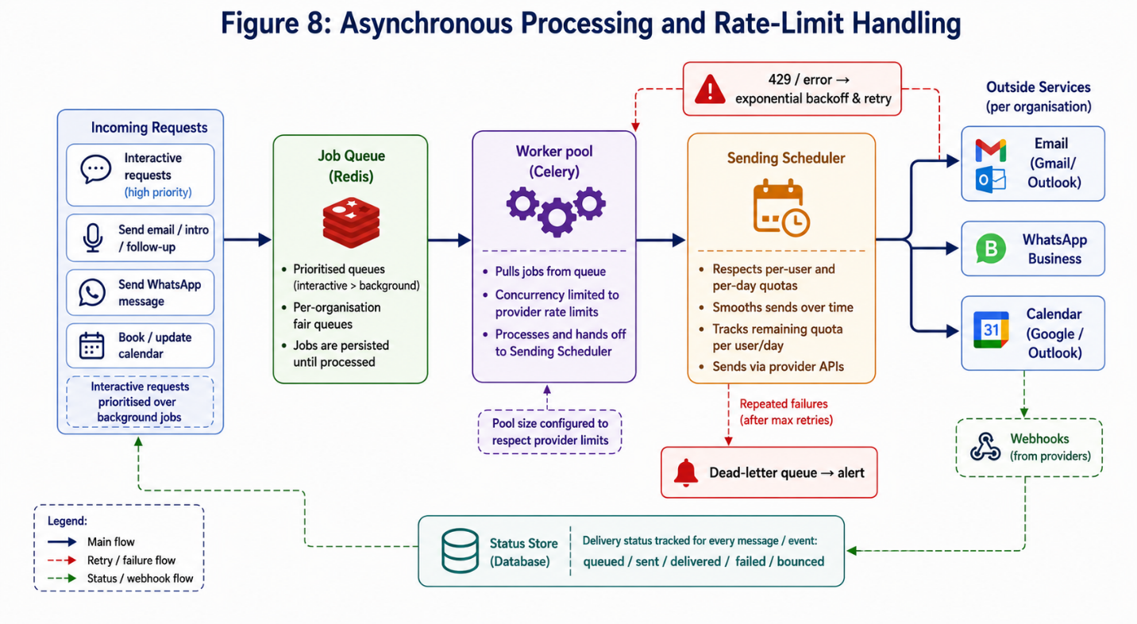

11.7 Fairness between organisations (no noisy neighbour)
Per-organisation rate limits and fair queues stop one very busy organisation from slowing everyone else down. Quick interactive requests (“show my tasks”) are given priority over heavy background jobs (transcription).

11.8 Room to grow per organisation
Most organisations share one database safely. If a single very large organisation needs more, we move just that one to its own dedicated database (a hybrid model) while everyone else stays shared. Because every record already carries an org_id and the app already filters by it, this is a configuration change, not a redesign.

Example — a million action items, still fast: Across all organisations there are a million action items. Rahul asks “Show my open action items.”
The query filters by (org_id = YuviPep, owner = Rahul, status = Open). Thanks to the index on those columns, the database returns Rahul’s handful of tasks in milliseconds — it never reads the other rows. As data grows, partitioning, caching, and read replicas keep it that way. Meanwhile the AI-call controls in 11.5 keep cost and waiting time in check, which is where the real pressure sits.

12. Reliability and Correctness
A sales tool must not make embarrassing or costly mistakes. These rules keep the system trustworthy.
Numbers never come from the AI. Prices and totals come straight from the organisation’s pricing table. The AI only writes the words around them. This makes it impossible for a proposal to show a made-up price.
Proposals lock their versions. Each proposal stores the exact template and pricing version it used. If pricing changes next month, old proposals stay exactly as they were sent.
No double sends or duplicates. Every send or save carries an idempotency key. If a request is retried after a dropped connection, the system recognises it and does not send the same email twice or create duplicate tasks.
Retries, then a safety net. Background jobs that fail are retried with backoff. If something still fails after several tries, it goes to a dead-letter queue and raises an alert, so a human can step in. Nothing is lost silently.
Low confidence is flagged, not hidden. If a transcript or a card scan is unclear, the app marks it for the user to fix rather than guessing. Client messages always need a one-tap human approval.
Clear rules when two people touch one record. If two people edit the same proposal or change the same task, the system keeps the last change and records both in the activity log; a record being edited can show a gentle “someone else is editing” notice.
We can see what the agents are doing. Every agent step is traced (LangSmith or Langfuse) with its result, time taken, and cost. Dashboards and alerts catch error spikes early.
Offline and poor signal are handled. Meetings can be recorded with no signal and upload later. If a model call or upload fails, the recording is kept safely and the user can retry.

13. Security and Access Control
Because this holds private meeting recordings and customer details for several organisations, security matters a lot. The main rules:
- Organisation isolation. Every record carries an org_id, and the database (Row-Level Security) only returns rows for the logged-in person’s organisation. One organisation can never see another’s data, even by accident.
- Email = identity. Each person logs in with their official company email, tied to one organisation. No shared logins.
- Role-based access. Your role decides what you can do. A Sales Agent cannot change pricing; only an Org Admin can. Only the Super Admin can create organisations.
- Safe connections to outside accounts. Each organisation’s Gmail, WhatsApp, and Calendar access uses OAuth tokens kept encrypted and refreshed automatically. API keys and secrets live in a secrets manager, never in the code.
- Encryption. All data is encrypted when stored and when sent. Encryption keys are managed by a key service, not hard-coded.
- Human approval for sending. No proposal, intro message, or email goes out without a person tapping Approve.
- Activity log. The system records who did what, per organisation, for safety and review.
Sample access rules (who can do what):

Action | Sales Agent | Sales Lead | Org Admin | Super Admin
Record a meeting | Yes | Yes | Yes | No
Send a proposal (own deal) | Yes | Yes | Yes | No
Move a task to another person | Own only | Whole team | Yes | No
Edit a pricing table | No | No | Yes | No
Add a program or template | No | No | Yes | No
Register staff / set access | No | No | Yes | No
Create a new organisation | No | No | No | Yes
See another organisation’s data | No | No | No | No

13.1 Room for finer-grained access later
The seven roles above are enough for the current size. As organisations grow past a few teams, the design leaves room to add custom roles and per-team data scoping — for example, an agent who can see only their own region’s leads, or a read-only manager role. Because access is already checked centrally on every request, these can be added without changing the core model.

14. Data Protection, Retention, and Compliance
This system records real conversations and stores personal details — names, emails, phone numbers, and voices. We treat that seriously and align the design with India’s Digital Personal Data Protection (DPDP) Act, 2023. (This is a planning view, to be confirmed with a legal advisor.)
Consent before recording. Before a recording starts, the app makes sure the other person was told and agreed, and logs that consent. Recording is used only for sales follow-up, nothing else.
Store only what is needed. We keep the contact and meeting details the sales job needs, and no more.
Retention limits. Audio and transcripts are kept only for a period set by each organisation, then deleted or archived automatically. Raw audio can be removed sooner than the text summary, since the heavy voice file is rarely needed once the notes exist.
The right to be removed. If a person asks to be deleted, we can remove their personal data and recordings across the database, the files, and the memory store — not just hide them.
Where the data lives. Data is stored in an India region. We document what leaves the system: transcripts go to the model provider (Gemini or Claude) for processing under a data-processing agreement, and obvious personal details can be masked before sending where practical.
Backups and recovery. Encrypted backups run regularly, with a defined recovery point and recovery time, and restores are tested. Deleted data is also purged from backups within the backup cycle.
When an organisation leaves. Its data is exported back to it and then securely deleted from the platform.
Audit and breach response. Access to personal data is logged. A clear plan covers detecting, containing, and reporting any data breach as required.

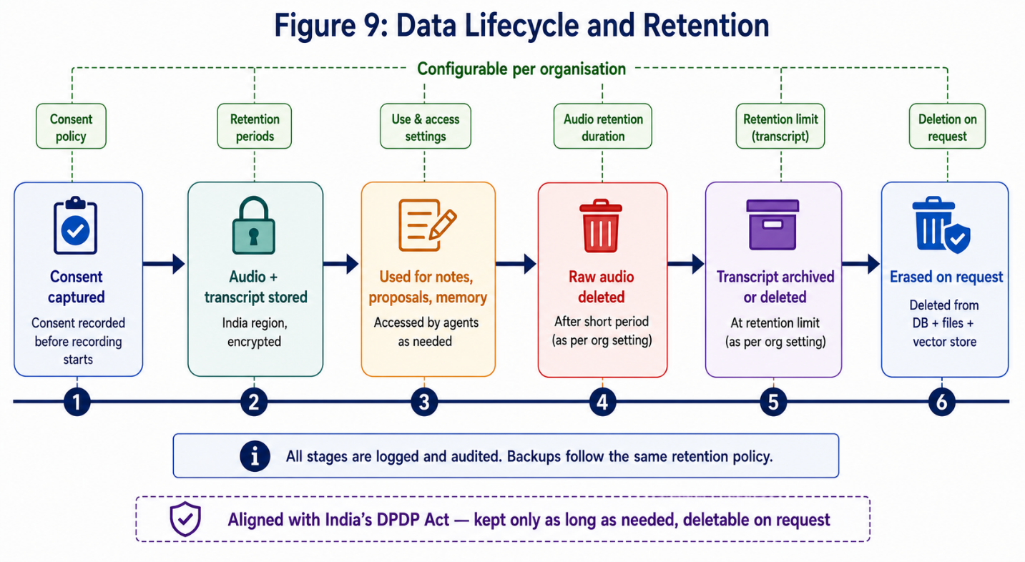

15. Organisation Onboarding
This explains how a new organisation joins the platform. It is done once per organisation, mostly by the Super Admin and the new organisation’s first Admin.

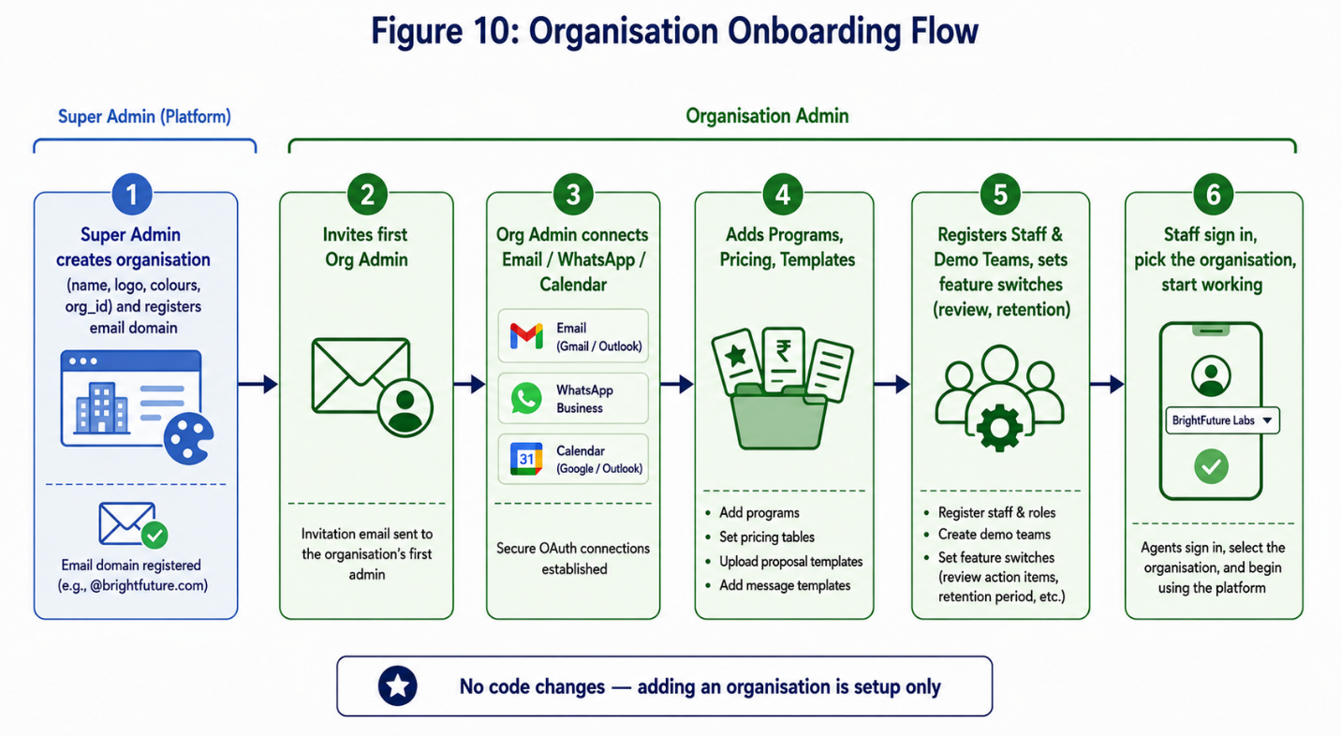

- The Super Admin creates the organisation: name, logo, colours, and a unique org_id. The email domain is registered (for example, @brightfuture.com).
- The Super Admin invites the organisation’s first Org Admin by email.
- The Org Admin connects the organisation’s own email (Gmail/Outlook), WhatsApp number, and calendar.
- The Org Admin adds programs, pricing tables, proposal templates, and message templates.
- The Org Admin registers staff and demo teams, and sets feature switches (such as “review action items” and retention period).
- Staff download the app, pick the organisation at sign-in, and start working.
Nothing is shared by mistake: from the moment the org_id is created, every record the new organisation makes is stamped with it and fenced off from all others. No code changes are needed to add an organisation — it is all setup.

Example — BrightFuture joins in an afternoon: The Super Admin creates BrightFuture Labs, registers @brightfuture.com, and invites Meena as Org Admin.
Meena connects BrightFuture’s Gmail, adds her Robotics program with its own pricing and templates, registers her sales team, and sets the retention period. Her agents sign in, pick BrightFuture, and record their first meetings that same day. YuviPep notices nothing — the two run side by side, fully separate.

16. What Else Is Possible (Extra Ideas)
Once the core is built, the same system can do more, with little extra work:
- Daily summary. Each morning, a short plan for each agent: today’s follow-ups, demos, and open tasks.
- Lead scoring. The AI guesses which schools are most likely to say yes, so staff focus there first.
- Multilingual support. Record and understand meetings in Hindi and other Indian languages, not just English.
- Voice assistant. Hands-free use while driving: “What are my meetings today?”
- Manager dashboard. A live view of pipeline, demos, and team workload — per organisation.
- Auto next-step. After a proposal, the AI suggests the best next action and sets the reminder.
- Platform dashboard for the Super Admin. How many organisations are active and how the platform is performing — without reading private sales data.
- Speaker separation. Tell who said what in a recording, so action items are tied to the right person.
- Offline mode. Record even with no signal; upload later when back online.

17. Suggested Build Plan (Phases)
We build in stages so we can use the system early and improve it over time. The multi-organisation foundation goes in from Phase 1, because it is far easier to build in than to add later.

Phase | What we build | Result
Phase 1 (MVP) | Multi-organisation foundation (org_id + Row-Level Security) + login + record + transcript + action items (with optional review) + business card reading + intro message + save to database. | Meetings turn into notes and tasks automatically, inside each organisation.
Phase 2 | Proposal creation and editing (prices from the table, versioned) + email sending with approval, queuing and backoff + org-admin setup. | Full proposal-to-email flow works end to end and respects send limits.
Phase 3 | Status fetch, demo details (list + calendar view), follow-ups, WhatsApp, calendar, organisation onboarding, retention and deletion controls. | Day-to-day work is fully covered; new organisations self-onboard; data rules are enforced.
Phase 4 | Switch main model to Claude, add dashboards, lead scoring, multilingual, and scale features (partitioning, caching, read replicas, dedicated vector store). | Smarter, cheaper, more languages, and ready for heavy load.

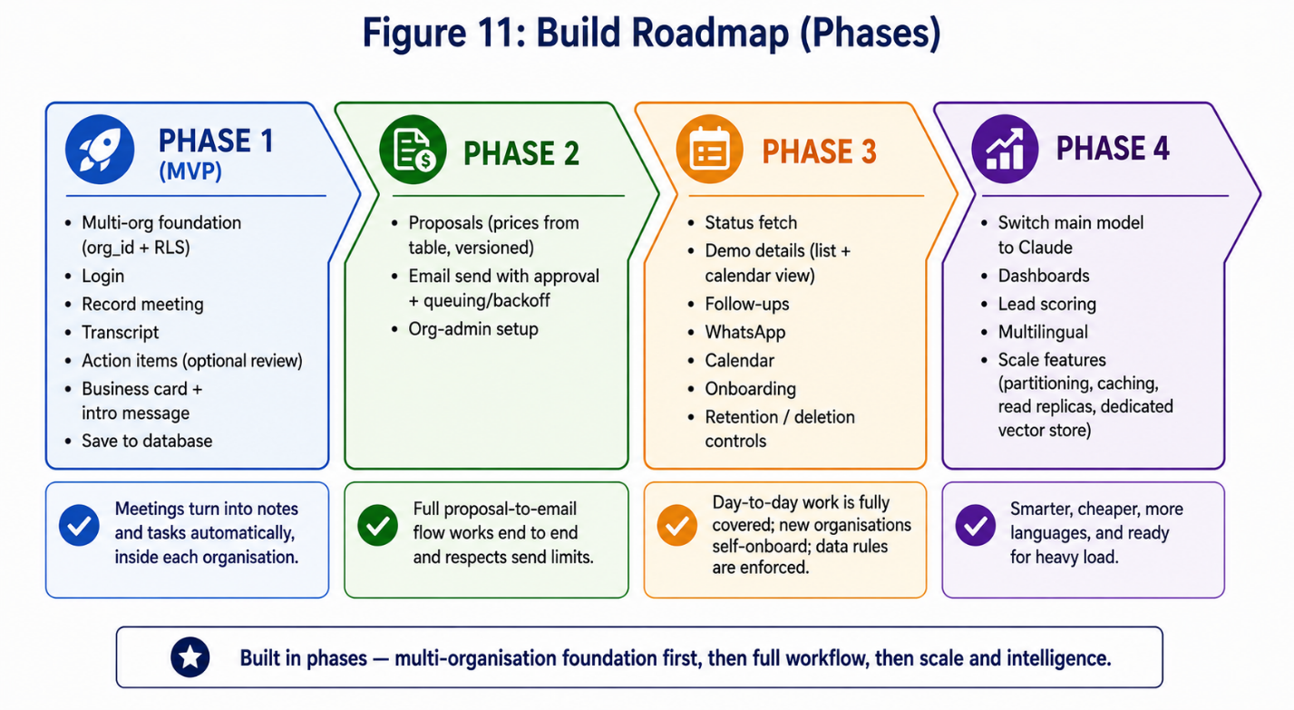

18. Things to Be Careful About
Being honest about the hard parts helps us plan well.
- Organisation isolation must be perfect. A leak across organisations would be serious. That is why we use both app-level filtering and database Row-Level Security, and test isolation carefully.
- The AI must never invent numbers. Prices come from the pricing table, not the model. The model only writes the wording.
- AI can make mistakes. That is why a person always approves before anything reaches a client.
- The AI calls cost money and time. The chain of model calls is the real pressure point. We control it with cheaper models for simple steps, reuse, concurrency limits, and per-organisation budgets.
- Outside services have limits. Email, WhatsApp, and calendar APIs cap daily volume. We queue, spread out, and back off rather than fire sends directly.
- Recordings are sensitive. We follow consent rules, store recordings safely, and delete them on time (Section 14).
- Audio quality. Noisy rooms or strong accents can lower transcript quality. We pick a strong speech tool and let staff fix text easily.
- Change for staff. People are used to Salesforce. We need simple training and a smooth handover.
- Privacy of customer data. School and contact data must be protected and never leaked — not to outside parties, and not to other organisations on the platform.

19. Summary
We plan to build a phone app, backed by a Python system, that turns sales meetings into finished work on its own. The salesperson talks; the AI listens, writes the notes, finds the tasks (with an optional review), reads the business card, sends a warm introduction, builds the proposal, and sends the email — with just one approval tap.
The brain is a set of small AI agents built with LangChain and LangGraph. They use Gemini now and Claude later, with a simple switch (LiteLLM) so we never have to rebuild.
The platform serves many organisations. Each one — starting with YuviPep — has its own private space, programs, pricing, templates, teams, and email, kept separate by an org_id on every record and guarded by the database itself. New organisations join with setup alone, no rebuild.
The design is built to last under real load. The fastest-growing tables are partitioned and archived; hot data is cached; the memory store has a clear path to scale; the chain of AI calls — the true bottleneck — is kept cheap and fast; and outside-service limits are handled with queues and backoff. Personal data is protected, kept only as long as needed, and deletable on request, in line with the DPDP Act.
We build in phases, with the multi-organisation foundation first, then recording and notes, then proposals and email, then the full daily workflow and scale features. The end result is the “zero-touch” goal: far less manual work than Salesforce, fewer missed tasks, and faster proposals — for any number of organisations — while a human still gives the final yes before anything reaches a customer.

